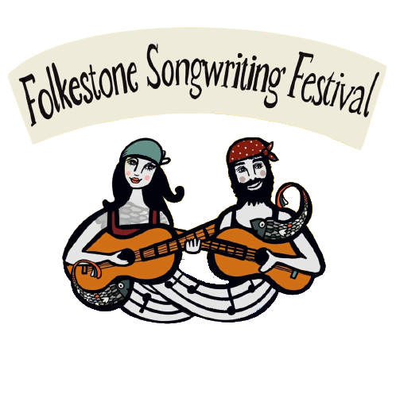

Folkestone Songwriting Festival 2023

Scholarship Application.

**Preferred name:**

________________________________________________________________

**Preferred Pronoun:**

________________________________________________________________

**Age group:**

16 – 19 **//** 20 -25 **//** 25 – 30 **//** 30 – 40 **//** 40 – 50 **//** 50 – 60 **//** 60 – 70 70 – 80 **//** 80+

**Home address:**

________________________________________________________________

________________________________________________________________

________________________________________________________________

**Why are you applying for a festival scholarship?**

________________________________________________________________________________________________________________________________

________________________________________________________________

**Do you have any additional needs with regards to diversity and inclusion?**

________________________________________________________________

________________________________________________________________

________________________________________________________________

**What would you rate your musical and or writing experience as?**

Never written a song before

I don’t play an instrument

I have some experience

I have loads of experience

**Anything else you would like to add to support your application?**

________________________________________________________________

________________________________________________________________

________________________________________________________________

________________________________________________________________

________________________________________________________________

**Signed:**

__________________

**Date:**

__________________